Haroutun Haroutunian

Professor Berhe

ECE 443L

5 March 2022

**Lab 3: CMOS Transistor Level Utility Amplifier Design**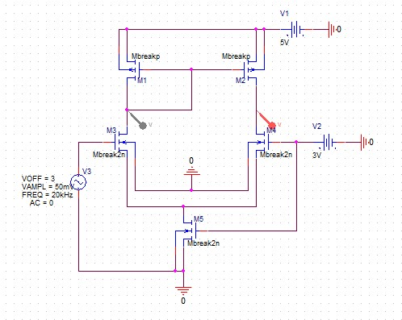

Figure 3.1: CMOS Transistor Amplifier Design with Double Sizing and V(m) @ 50mV and Freq @ 20kHz

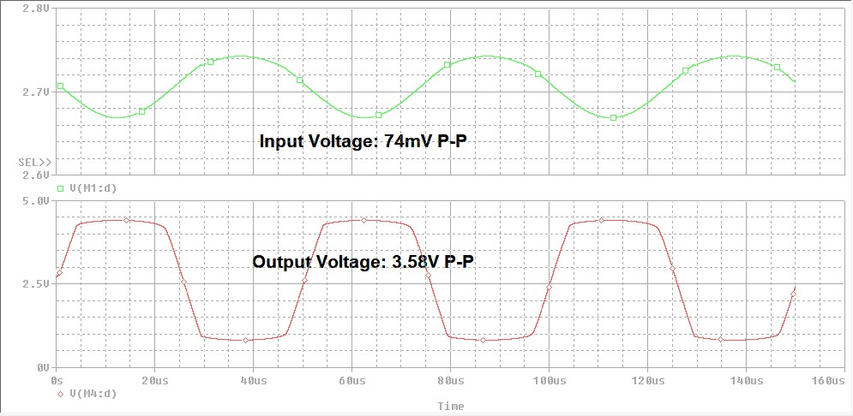

Figure 3.2: CMOS Transistor Amplifier Waveform and Cursor with Double Sizing and A(v) @ 48.38V

Figure 3.3: CMOS Transistor Amplifier Design with Triple Sizing and V(m) @ 35mV and Freq @ 25kHz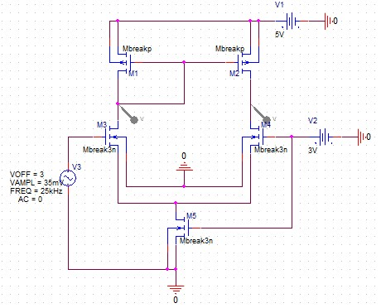

Figure 3.4: CMOS Transistor Amplifier Waveform and Cursor with Triple Sizing and A(v) @ 67.27V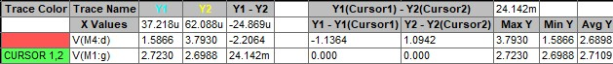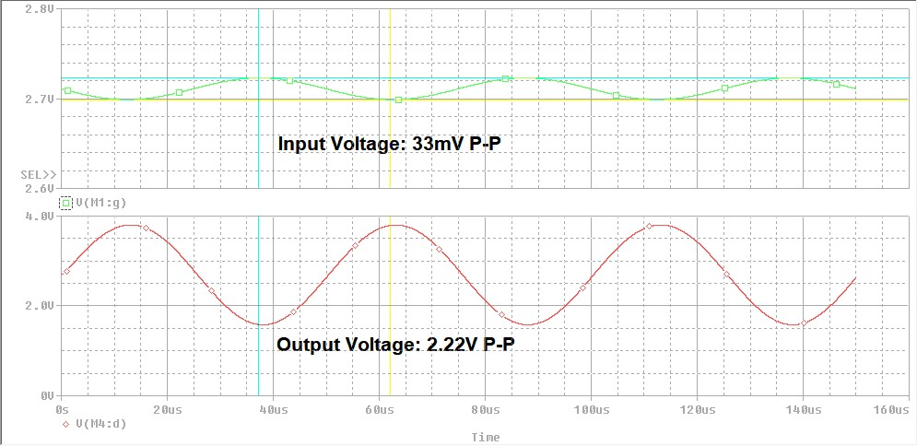

Figure 3.5: CMOS Transistor Amplifier Design with Quadruple Sizing and V(m) @ 20mV and Freq @ 40kHz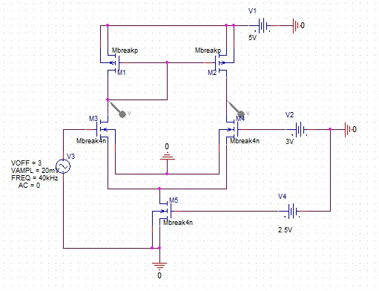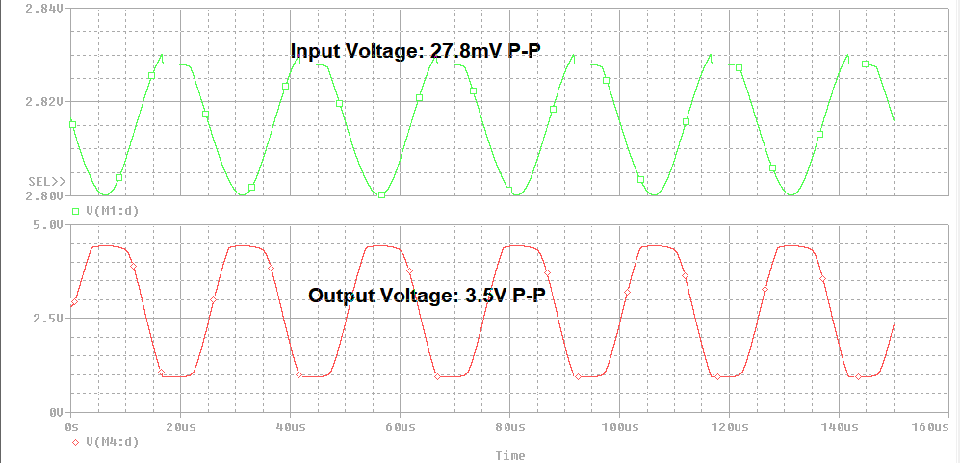

Figure 3.6: CMOS Transistor Amplifier Waveform and Cursor with Quadruple Sizing and A(v) @ 125.9V